DO IT – Front End developer

Mini project 7 – Final appearance – HTML - CSS

SMART d.o.o, New Frontier Group

Version: 1.0

Revision date: July 26, 2016

Table of Contents

Specification of mini project 2

Requirements for this project 3

Tasks 4

Timeline 5

Tools 6

# Specification of mini project

In this mini project you will construct final look of your web site with all pages that were made during working on mini projects and it will look like pages miniproject7-1.jpg, miniproject7-2,. miniproject7-3.jpg jpg shows.

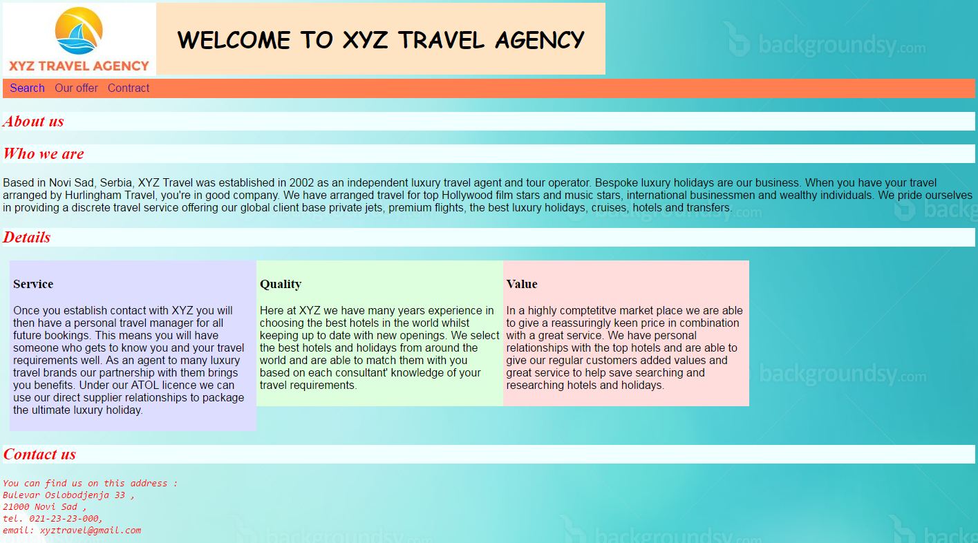

Picture 1 – miniproject7-1.jpg

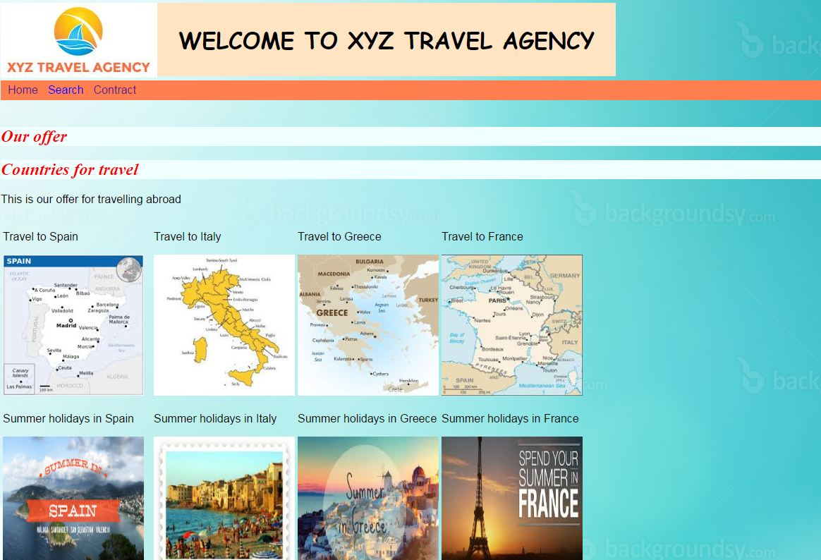

Picture 2 – miniproject7-2.jpg

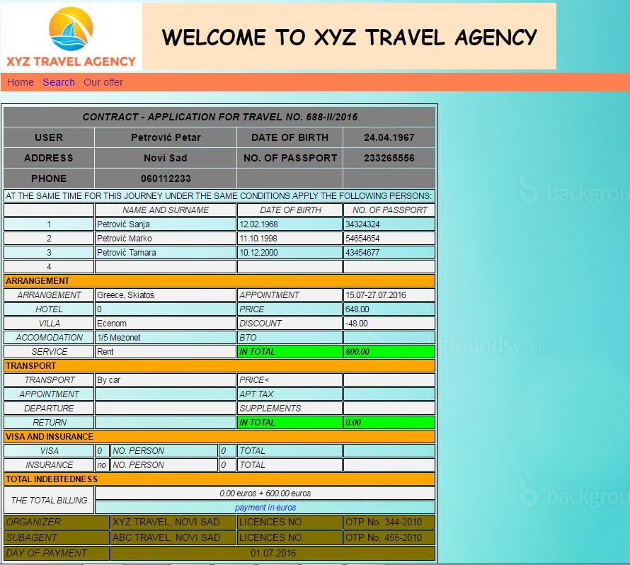

Picture 3 – miniproject7-3.jpg

# Requirements for this project

Before you can start with this project you need to finished all classes from Section 1.

**Tasks**

So your job is to do next :

1. You will work on pages from previous mini projects. You will use newdesign.html from mini project 6 , then pictures.html from mini project 3 and contract.html from project 5
2. Now you will need to change html and css code for those pages.
3. Start with newdesign.html page and first delete all from h1 tag till h2 tag.
4. Then insert one div tag and put id tag with header name.
5. After that make two more div inside header div and put id tag with name logo in first div and id tag with name title in second one.
6. Inside div logo insert image logoxyz.JPG from images folder and put alternate text as Travel agency with width 222 and height 106.
7. In title div put in h1 text WELCOME TO XYZ TRAVEL AGENCY
8. After second div put br with class name clear.
9. Now you must create another div with class name menu.
10. Inside this div put three links , first is called Search, second Our Offer and third one Contract. Reference for Search link is <http://www.google.com>, for Our offer is pictures.html and for Contract is contract.html
11. After links put br with class name clear.
12. There are no more changes on page newdesign.html
13. Now we need to change style.css.
14. In h1 selector add padding 30px and set top margin to 0.
15. In a selector delete float property and border style property, change padding to 5 px and set font family to sans serif
16. Change pseudo class hover and delete color property , then add background color to aqua and padding to 5px.
17. Delete width property in details class selector.
18. Now add id selector which is called header. Put position property to relative value. Also put top and left property to 0 px
19. Add id selector and call it logo and put property position to relative with float to left.
20. Create new id selector and call it title with absolute position with left float. Put left property to 222px and top property to 0.
21. Finally make class selector menu with background color with coral value and made padding to 5 px.

**Additional tasks**

1. Now you need to change other two pages.
2. In both contract.html and pictures.html insert link to style.css file .
3. Also from contract.html copy part of code where is logo,title and links and adjust menu in contract and pictures pages so that looks like in pictures.
4. Save and refresh pages and test final website.

Your result should look like on pictures miniproject7-1.jpg, miniproject7-2.jpg, miniproject7-3.jpg

Good luck!

# Timeline

You will have 4 hours to finish this job.

This timeline is for main parts of the task. Bonus parts should be implemented only if there is extra time left.

# Tools

## IDE and Source Control

You can use either Atom or Brackets tool for development during this project

ATOM - <https://atom.io/>

BRACKETS - <http://brackets.io/>